ACHIEVING A SAFER AND MORE EFFECTIVE TRANSPORTATION SYSTEM IN NIGERIA THROUGH INFORMATION TECHNOLOGY
By: Odunayo Eluwole
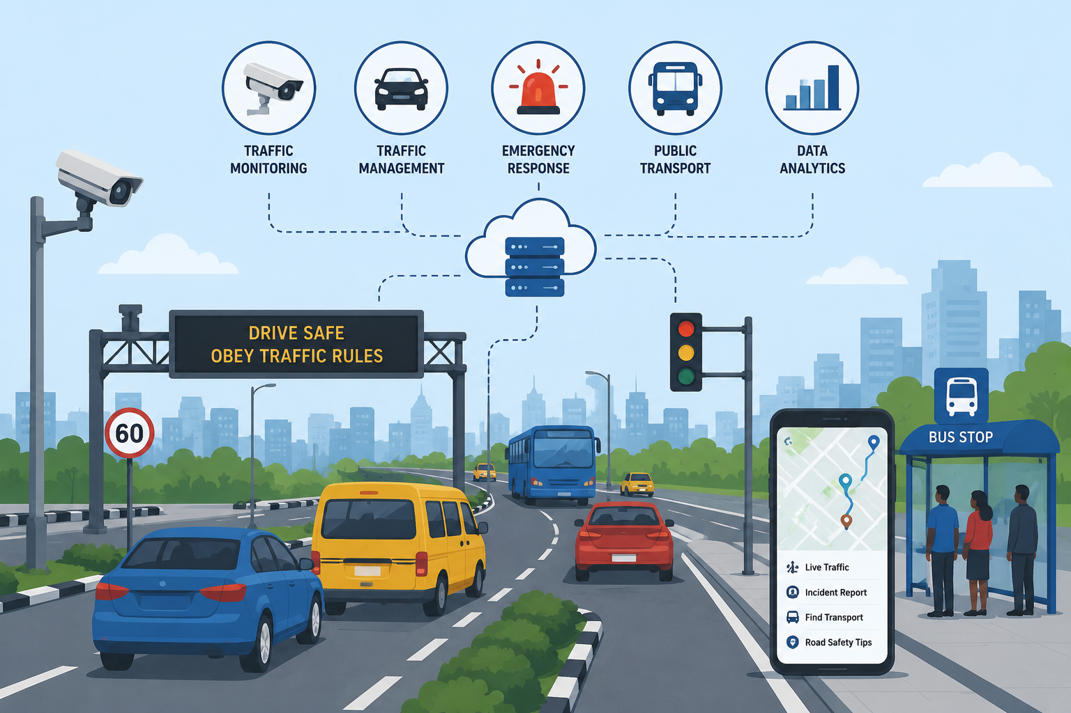

Transportation is the backbone of economic growth and social development.
In a country as populous and dynamic as Nigeria, an efficient transportation system is essential for trade, education, healthcare access and national integration.
However, Nigeria’s transport sector faces persistent challenges such as road accidents, traffic congestion, poor infrastructure maintenance, insecurity and inefficient public transport operations.
Leveraging Information Technology (IT) offers a transformative pathway towards building a safer, smarter and more efficient transportation system.
- Road safety monitoring and enforcement: Road accidents remain a major concern in Nigeria. Information technology can strengthen road safety enforcement in several ways;
- Speed detection cameras and automated ticketing systems.
- Digital reporting platforms for road incidents.
- Data analytics to identify accident – prone zones.
- Mobile apps for emergency response coordination.
- Promoting sustainable and smart mobility: Information technology also supports environmentally sustainable transportation and smart mobility solutions such as ride- sharing platforms, electric vehicle infrastructure monitoring and traffic optimization software – reduce congestion and emissions.
Urban planning supported by IT can promote multimodal transport systems that integrate buses, rail and non-motorised transport. Data analytics can help determine where to build new roads, rail lines or pedestrian pathways based on actual usage patterns.
- Capacity building and public awareness: Technology implementation must be accompanied by training and public education. Transportation officials, law enforcement officers and drivers must be trained to use digital systems effectively. Public awareness campaigns can encourage compliance with traffic laws and the adoption of digital platforms.
In conclusion, achieving a safer and more effective transportation system in Nigeria requires more than physical infrastructure. It demands intelligent systems powered by information technology.
By embracing digital transformation, strengthening institutional capacity and fostering collaboration between government and the private sector, Nigeria can significantly reduce road accidents, improve mobility, and enhance security and economic growth.

